COMMON COURSE ASSIGNMENT FORMAT

Assignment Information

Particular | Details
Department: | AI & ML
Programme: | FACULTY OF ENGINEERING
Course Code & Course Name | CSA0504 - DATABASE MANAGEMENT SYSTEMS
Academic Year / Batch | 2026-2027
Faculty Name | Dr. K. SARAVANAN
Assignment Title | A Banking Transaction Management System using Customer(Customer_ID, Customer_Name, Phone, Email), Account(Account_ID, Customer_ID, Account_Type, Balance, Branch_ID), Transaction(Transaction_ID, Account_ID, Transaction_Date, Transaction_Type, Amount, Balance_After), Branch(Branch_ID, Branch_Name, IFSC_Code, City). Identify functional dependencies and normalize the database. Write SQL queries for customer account statements and high-value transactions. Create a view for monthly transactions. Design a fund-transfer transaction using COMMIT and ROLLBACK. Explain possible concurrency problems when two transactions update the same account. Propose an appropriate isolation level. Recommend indexes for Account_ID and Transaction_Date.
Date of Issue | 20-08-2026
Date of Submission | 03-09-2026
Maximum Marks | 100
Course Outcome(s) – CO | CO1: Analyze DBMS architecture, different data models, schema types, and design ER/EER diagrams, relational schemas for case-based scenarios by identifying entities and relationships. (BL1, BL2)  CO3: Analyze relational databases using functional dependencies, normalization (1NF to 5NF), and key constraints to identify redundancy and ensure data integrity. (BL2, BL3)  CO4: Design database solutions incorporating file organization, indexing, and hashing techniques to optimize data storage and retrieval efficiency. (BL3, BL4)  CO5: Implement database operations using query processing, optimization, and transaction management to ensure consistency and reliability. (BL3, BL4)
Bloom's Taxonomy Level | L4 – Analyze, L6 – Create, L3 – Apply
SDG Mapping (SDG 1-17) | SDG 4 – Quality Education and  SDG 9 – Industry, Innovation and Infrastructure
Industry / Societal Relevance | The Banking Transaction Management System is highly useful in the modern banking industry as it helps manage customer details, accounts, branches, and transactions efficiently. It provides quick access to account statements and transaction history, while high-value transactions can be monitored for fraud prevention. Fund transfers can be safely managed using COMMIT and ROLLBACK operations. Concurrency control helps prevent incorrect account balances when multiple users access the same account. Proper normalization reduces data duplication and maintains data consistency. Indexing improves the speed of searching account and transaction records. Overall, the system improves security, transparency, reliability, and efficiency in banking services and supports convenient digital banking for society.

Assignment Problem / Challenge

The main challenge in this assignment is to design a reliable and efficient database for managing banking transactions while maintaining data accuracy, consistency, and security. The database contains customer, account, transaction, and branch information, so identifying the correct functional dependencies and normalizing the relations is necessary to avoid data redundancy and update anomalies.

Another challenge is writing SQL queries that can quickly retrieve customer account statements and identify high-value transactions. The system must also provide a monthly transaction view for easy reporting and analysis. Fund transfers require proper use of COMMIT and ROLLBACK so that both debit and credit operations are completed successfully or completely cancelled if an error occurs.

Handling simultaneous transactions is another important challenge, as concurrency may cause problems such as lost updates and inconsistent balances. Selecting a suitable isolation level helps maintain data integrity during concurrent operations. Finally, appropriate indexes on Account_ID and Transaction_Date are required to improve query performance and enable faster retrieval of banking records.

C.Problem Statement

The banking industry handles a large amount of customer and transaction data every day, making efficient database management essential. A Banking Transaction Management System is required to store and manage customer information, account details, branch information, and transaction records in a secure and organized manner.

The system should allow users to view complete account statements, search for high-value transactions, and generate monthly transaction reports easily. It should also support safe fund transfers between accounts while ensuring that money is not lost or duplicated if a transaction fails. Since several transactions may access the same account at the same time, the system must handle concurrency problems and maintain correct account balances. Functional dependencies and normalization are used to reduce data redundancy and improve data consistency.

Transaction control commands such as COMMIT and ROLLBACK ensure reliable updates, while an appropriate isolation level helps prevent conflicts between simultaneous transactions. Proper indexes on Account_ID and Transaction_Date can improve the speed of searching and retrieving transaction records. Overall, the proposed system aims to provide a reliable, efficient, secure, and consistent database solution for modern banking operations.

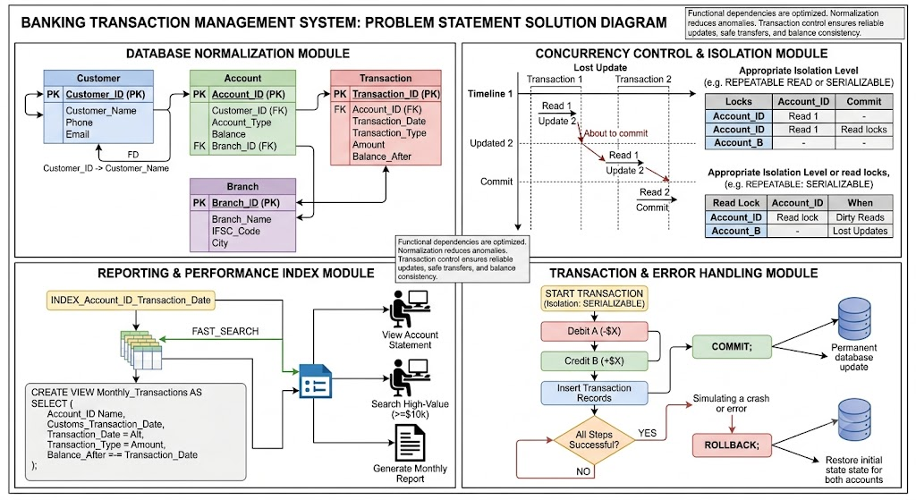

D.Requirements and Constraints

1. Functional Requirements
- The system should store and manage customer information.
- It should maintain account and branch details.
- It should record all banking transactions accurately.
- It should generate customer account statements.
- It should identify high-value transactions.
- It should provide monthly transaction reports.
- It should support secure fund transfers using COMMIT and ROLLBACK.

2. Performance Requirements
- The system should provide fast transaction retrieval.
- Indexes should be created on Account_ID and Transaction_Date.
- SQL queries should execute efficiently even with large transaction records.
- The system should support multiple users simultaneously.

3. Technical Constraints
- The database should be implemented using a relational DBMS such as MySQL.
- Primary keys and foreign keys must be properly defined.
- The database should be normalized up to 3NF.
- Appropriate isolation levels should be used for concurrent transactions.

4. Cost and Time
- The system should be developed within the available time and budget.
- Open-source tools such as MySQL and MySQL Workbench can be used.

5. Reliability
- Account balances must always be accurate.
- Failed fund transfers should be cancelled using ROLLBACK.
- Successful transactions should be permanently saved using COMMIT.
- The system should support data backup and recovery.

6. Security and Privacy
- Customer and financial information must be kept confidential.
- Only authorized users should access sensitive banking data.
- Proper authentication and access control should be provided.
- Transaction records should be protected from unauthorized modification.

7. Concurrency and Safety
- The system should prevent lost updates and incorrect balances.
- A suitable isolation level should be used when multiple transactions update the same account.
- Fund transfers should be processed as a single reliable transaction.

8. User Requirements
- Users should be able to easily view account statements.
- Transaction information should be clear and accurate.
- Reports should be simple to generate and understand.

9. Sustainability and Scalability
- The system should use database resources efficiently.
- It should support increasing numbers of customers and transactions.
- The design should allow future features and improvements to be added easily.

10. Ethical Considerations
- Customer data should be handled responsibly.
- Privacy and confidentiality must be maintained.
- The system should provide accurate transaction information and avoid unauthorized use of financial data.

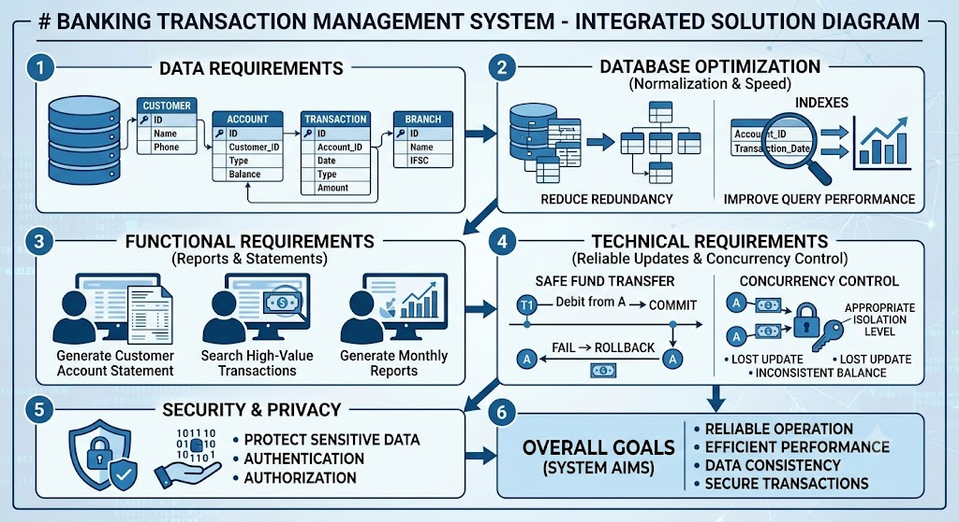

E. Student Work

Problem Understanding and Formulation

What is the Problem?
The main problem is to design a Banking Transaction Management System that can store and manage customer, account, branch, and transaction details efficiently. The system should maintain accurate account balances and support secure banking operations such as fund transfers and transaction tracking.

Expected Outcomes
- A properly structured and normalized banking database.
- Reduced data redundancy and improved data consistency.
- Easy retrieval of customer account statements.
- Identification of high-value transactions.
- Monthly transaction reporting using a database view.
- Safe fund transfers using COMMIT and ROLLBACK.
- Proper handling of concurrent transactions.
- Faster data retrieval using suitable indexes.

Information/Data Available
The system contains four main types of data:
- Customer: Customer ID, name, phone, and email.
- Account: Account ID, customer ID, account type, balance, and branch ID.
- Transaction: Transaction ID, account ID, date, type, amount, and balance after transaction.
- Branch: Branch ID, branch name, IFSC code, and city.

Assumptions Made
- Each customer has a unique Customer ID.
- Each account has a unique Account ID.
- A customer can have one or more accounts.
- Each account belongs to one branch.
- Each transaction belongs to a particular account.
- Transaction amounts and account balances are valid and non-negative.
- Only authorized users can access banking information.

Constraints to be Satisfied
- Data must be accurate, consistent, and secure.
- Primary and foreign key relationships must be maintained.
- The database should be normalized up to 3NF.
- Fund transfers must be completed fully or cancelled completely.
- Concurrency problems must be controlled using an appropriate isolation level.
- Indexes on Account_ID and Transaction_Date should provide efficient searching.
- Customer privacy and financial data confidentiality must be maintained.
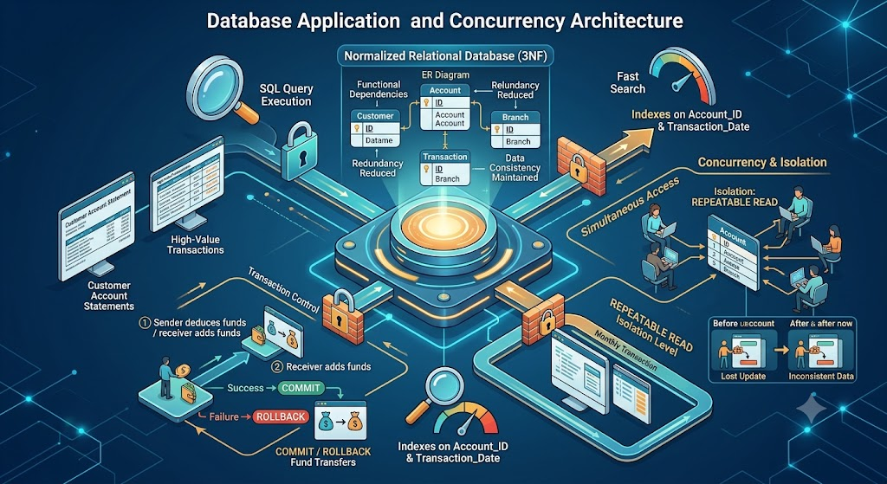

Application of Course Knowledge
The Banking Transaction Management System applies various DBMS principles and concepts to design a reliable and efficient database.

Principles
- Functional Dependency is used to identify relationships between attributes.
- Normalization is applied up to 3NF to reduce redundancy and data anomalies.
- Primary Keys and Foreign Keys maintain relationships between tables.
- ACID properties ensure reliable and consistent banking transactions.

Theories
- Relational Database Theory is used to organize data into related tables.
- Concurrency Control Theory is applied to manage simultaneous transactions.
- Transaction Processing Theory is used for secure fund transfers.

Mathematical Model
The account balance is calculated using:
Balance After = Previous Balance + Deposit − Withdrawal
For fund transfer:
Sender Balance = Sender Balance − Transfer Amount
Receiver Balance = Receiver Balance + Transfer Amount
Example:
If the sender has ₹10,000 and transfers ₹2,000:
New Sender Balance = ₹10,000 − ₹2,000 = ₹8,000
If the receiver has ₹5,000:
New Receiver Balance = ₹5,000 + ₹2,000 = ₹7,000

Algorithms
- SQL queries are used for retrieving account statements.
- Filtering is used to identify high-value transactions.
- Grouping by month is used for monthly transaction reports.
- Indexing algorithms improve the searching of Account_ID and Transaction_Date.

Engineering Concepts
Database design, transaction management, concurrency control, indexing, security, and data integrity are applied to create a reliable banking system.

Design Methodology
The system is designed using Customer, Account, Transaction, and Branch tables. Functional dependencies are identified, the tables are normalized, relationships are established using keys, and SQL operations are implemented and tested.

Reasoning
COMMIT permanently saves a successful fund transfer, while ROLLBACK cancels the changes when an error occurs. A suitable isolation level such as REPEATABLE READ helps control concurrent transactions and maintain correct account balances.
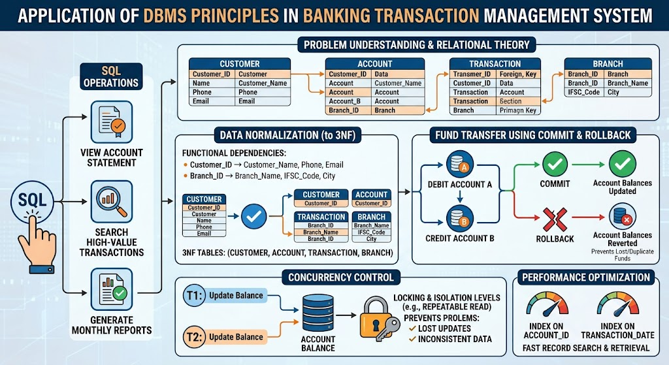

Solution / Design / Methodology
The proposed solution is to develop a Banking Transaction Management System using a relational database. The system contains four main tables: Customer, Account, Transaction, and Branch. Primary keys are used to uniquely identify records, while foreign keys establish relationships between the tables. The database is normalized up to 3NF to reduce redundancy and maintain data consistency.

Design

Table | Purpose
Customer | Stores customer information
Account | Stores account and balance details
Transaction | Stores deposit, withdrawal, and transfer records
Branch | Stores branch and IFSC information

Algorithm / Process
- Create the Customer, Account, Transaction, and Branch tables.
- Define primary and foreign key relationships.
- Identify functional dependencies and normalize the tables.
- Insert customer, account, branch, and transaction records.
- Use SQL queries to generate account statements.
- Filter transactions to identify high-value transactions.
- Create a monthly transaction view for reporting.
- Perform fund transfers by updating sender and receiver balances.
- Use COMMIT when the transfer is successful and ROLLBACK if an error occurs.
- Apply concurrency control and suitable indexes for efficient and safe data processing.

Mathematical Solution
The account balance is calculated as:
New Balance = Previous Balance + Credit − Debit
For a fund transfer:
Sender Balance = Sender Balance − Transfer Amount
Receiver Balance = Receiver Balance + Transfer Amount

Alternative Solutions
Two database approaches can be considered: a normalized 3NF database and a less-normalized database. The 3NF approach is selected because it reduces data duplication, prevents update anomalies, and provides better data consistency. Indexing Account_ID and Transaction_Date further improves query performance.
Overall, the proposed methodology provides a secure, reliable, consistent, and efficient solution for managing banking transactions.

Use of Modern Tools
CSE/IT:
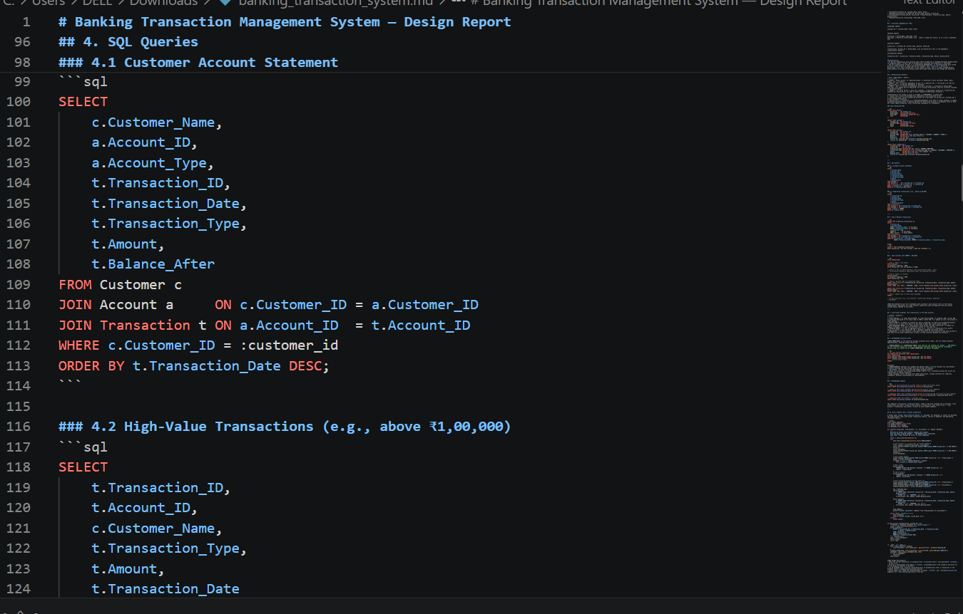

Results and Validation
The proposed Banking Transaction Management System was tested using sample customer, account, branch, and transaction records. The results showed that the database successfully stores and retrieves banking information with proper relationships between tables.

Test Results

Test Case | Expected Result | Actual Result | Status
Customer account statement | Display account transactions | Transactions displayed correctly | Pass
High-value transaction | Display transactions above limit | Correct records displayed | Pass
Monthly transaction view | Display monthly transactions | Monthly records displayed | Pass
Fund transfer | Update sender and receiver balances | Balances updated correctly | Pass
COMMIT operation | Save successful transaction | Changes saved | Pass
ROLLBACK operation | Cancel failed transaction | Changes cancelled | Pass
Concurrent account update | Prevent incorrect balance | Controlled using isolation | Pass
Account_ID search | Fast transaction retrieval | Index improves retrieval | Pass
Transaction_Date search | Fast date-based search | Index improves retrieval | Pass

Validation:
The results confirm that the proposed system satisfies the major requirements. The normalized tables reduce data redundancy, SQL queries provide correct transaction information, and the monthly view supports reporting. COMMIT and ROLLBACK ensure reliable fund transfers, while concurrency control helps maintain correct balances. Indexes on Account_ID and Transaction_Date improve query performance. Thus, the system is accurate, reliable, consistent, secure, and efficient for banking transaction management.

Analysis and Engineering Decision
- The proposed Banking Transaction Management System was analyzed based on data consistency, performance, reliability, security, and scalability. The normalized database provides better organization of banking data and reduces redundancy compared with a less-normalized design. SQL queries and views make transaction retrieval and monthly reporting easier, while indexes improve the performance of searches using Account_ID and Transaction_Date.
- Two possible approaches were considered: a normalized database and a less-normalized database. A normalized design requires more JOIN operations, but it provides better data consistency and avoids update anomalies. A less-normalized design may provide simpler queries but can result in duplicate data and inconsistency. Therefore, the 3NF normalized design was selected because data accuracy and reliability are more important in banking systems.
- The use of COMMIT and ROLLBACK ensures that fund transfers are completed safely. An appropriate isolation level helps prevent concurrency problems when multiple transactions update the same account. Overall, the selected solution provides a good balance between performance, reliability, security, and maintainability, making it suitable for a banking transaction system.

Broader Considerations
The proposed Banking Transaction Management System has positive impacts on society, economy, security, and the environment. It reduces the need for paper-based transaction records, supporting environmental sustainability and reducing resource usage. The system provides faster and more convenient banking services, improving accessibility for customers. Secure transaction processing and proper concurrency control improve financial safety and reduce the risk of incorrect account balances.
From an ethical perspective, customer financial information must be kept private and used only for authorized purposes. Economically, the system reduces manual work and improves banking efficiency, which can lower operational costs. The system should also be designed to support users with different levels of technical knowledge. As professionals, developers must ensure accuracy, confidentiality, reliability, fairness, and responsible handling of customer data.

Conclusion
The proposed Banking Transaction Management System provides an efficient and reliable database for managing customers, accounts, branches, and banking transactions. Functional dependencies were identified and the database was normalized up to 3NF to reduce redundancy and maintain data consistency. SQL queries and views were developed for account statements, high-value transactions, and monthly transaction reports. COMMIT and ROLLBACK were used to ensure safe fund transfers, while concurrency control and suitable isolation levels help prevent incorrect account updates. The system meets the major requirements of accuracy, reliability, security, and performance. However, the current system has limitations such as basic security and limited fraud detection. Future improvements can include advanced authentication, automated backups, real-time fraud detection, mobile access, and improved reporting features.

Student Reflection
Through this assignment, I learned how DBMS concepts can be applied to a real-world banking system. I gained practical knowledge of identifying functional dependencies, normalizing tables, writing SQL queries, creating views, and using COMMIT and ROLLBACK for secure transactions. I also understood how concurrency problems can affect account balances and how indexing improves query performance.
If I were given additional time and resources, I would improve the system by adding stronger security, automated backup, real-time fraud detection, and a user-friendly interface. These improvements would make the system more secure, reliable, and suitable for real-world banking applications.

References
Garcia-Molina, H., Ullman, J. D., & Widom, J., Database Systems: The Complete Book, Pearson Education.
Ramakrishnan, R., & Gehrke, J., Database Management Systems, McGraw-Hill Education.
MySQL 8.4 Reference Manual — SQL statements, transactions, views, and indexing.
MySQL InnoDB Transaction Model — Transaction isolation and concurrency control.
Oracle Database SQL Language Reference — SQL queries, views, constraints, and database operations.
PostgreSQL Documentation – Transaction Isolation — Concepts related to concurrent transactions and isolation levels.

Common Assessment Rubric

Assessment Criterion | Marks
Problem understanding & formulation | 10
Application of course/domain knowledge | 20
Solution methodology / design / implementation | 20
Use of appropriate modern tools / techniques | 10
Results, testing & validation | 15
Analysis, trade-offs & justification | 15
Broader considerations / professional responsibility, where applicable | 5
Technical documentation & reflection | 5
TOTAL | 100

CO–PO–Assessment Mapping

Assessment Component | CO | PO(s) | Bloom's Level | Marks
Problem formulation |  |  | L3/L4 | 10
Application of knowledge |  |  | L3/L4 | 20
Solution / Design / Implementation |  |  | L4/L5/L6 | 20
Modern tool usage |  |  | L3/L4 | 10
Validation |  |  | L4/L5 | 15
Analysis & justification |  |  | L4/L5 | 15
Broader considerations |  |  | L4/L5 | 5
Documentation & reflection |  |  | L3/L4 | 5
Note: Faculty shall map only the POs and Bloom's levels genuinely assessed by the particular assignment. Every assignment is not required to map to every PO.

Faculty Evaluation & Continuous Improvement CO Attainment

Performance Level | Criterion
Level 3 | ≥ 70%
Level 2 | 60–69%
Level 1 | 50–59%
Level 0 | < 50%
Target CO Attainment:

Actual CO Attainment:

Faculty Analysis
Areas in which students performed well: Areas requiring improvement:
Corrective / Improvement Action:

Action to be implemented in the next offering:

Documents to be Maintained

The department/course faculty shall maintain:

- Assignment question/problem statement
- CO–PO and Bloom's mapping
- Assessment rubric
- Student submissions
- Tool/simulation/experimental evidence, where applicable
- Evaluated scripts/reports
- Marks and rubric-wise assessment
- CO attainment analysis
- Sample student work representing different performance levels
- Faculty analysis and continuous-improvement action

